# What is Forex

## What is Forex

* Global market which allows trading two currencies against each other

## What is Traded in Forex?

* Forex trades **money** but not physically purchasing cash
* Exchange rate of a currency versus another currency is a reflection of the condition of that country’s economy
* Major currencies (CAD, GBP, EUR, JPY, CHF, NZD, USD)

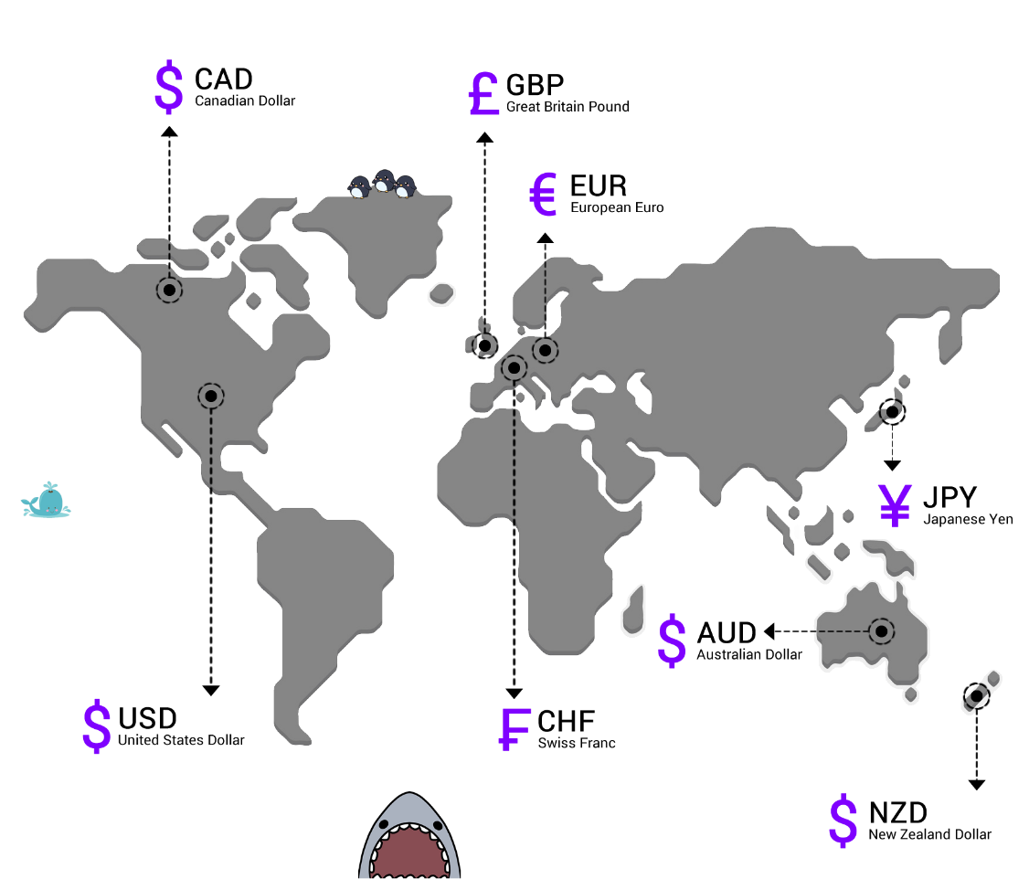s

* Currency symbols have **3 letters**: 2 for which country they are part of and 1 for the currency name

## Buying And Selling Currency Pairs

* Forex is the simultaneous buying of one currency and selling another
* Traded through a broker/dealer
* 3 categories of currency pairs:
  + Majors
  + Crosses
  + Exotics
* Majors always include the USD
* Cross-currency pairs do not include the USD (also called the minor pairs)
* Exotic pairs from a major currency + an emerging market (EM)

### Majors

* **Compared to the crosses and exotics, price moves more frequently with the majors, which provide more trading opportunities.**
* Liquidity describes level of activity in financial market – majors are most liquid
* More frequently traded something is = higher liquidity

### Crosses/minors

* Crosses of the major currency pairs (excluding the USD) are called crosses but also known as minors
* Not as frequently traded but still liquid
* Most active = EUR, JPY, GBP crosses

### Exotic pairs

* Made up of one major and an emergency economy (e.g. Mexico, Turkey, Hungary)
* Spreads will be much bigger than the ones for major pairs (2-3x bigger)
* Much more sensitive to economic/geopolitical events

## Forex Market Size and Liquidity

* Bulk of trading occurs on “interbank market”
* Entire market is run electronically within a network of banks, continuously over 24 hours
* Most actively traded currencies:

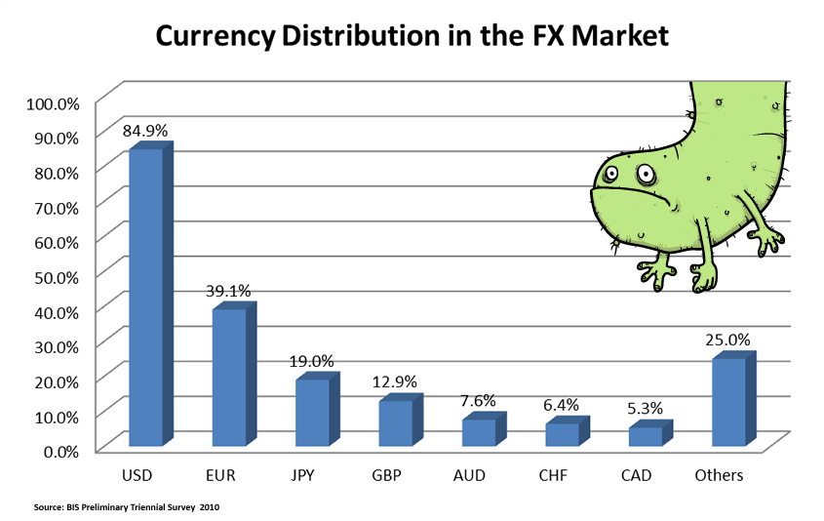

* USD is one-half of every major currency pair, and the majors comprise **75% of all trades**
* Many reasons that US economy is largest in the world:

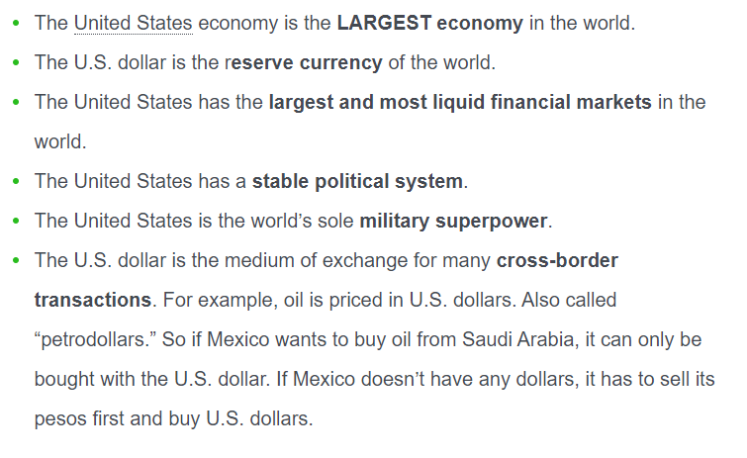

## Different Ways to Trade Forex

* Many different ways to trade: Retail forex, Spot FX, Currency Futures, Currency Options, Currency Exchange-Traded Funds (ETFs), Forex CFDs, Forex Spread Betting

**Futures:**

* Contracts to buy or sell certain assets at a specified price on a future date

**Options:**

* Financial instrument which gives the buyer the right or option but not obligation to buy/sell an asset at a specific price on the option’s expiration date
* Disadvantage in trading FX options is that market hours are limited for certain options and the liquidity is not nearly as great as the futures or spot market.

**Currency ETF’s**

* Exposure to a single currency or basket of currencies
* Allow ordinary individuals to gain exposure to the forex market through a managed fund – not individual trades
* Created/managed by financial institutions

**Spot FX**

* “Off-exchange” market – over the counter market
* Operates 24 hours
* Primary market for FX is the “interdealer” market where FX traders deal with each other
* Dominance of the market is by banks as FX dealers
* *Only accessible to institutions that trade in large quantities and have a very high net worth.*
* Generally the transaction will occur two business days after the trade date (T+2 = ‘today plus 2 business days’)

**Retail Forex**

* Secondary over-the-counter (OTC) market for retail traders
* Access is granted by forex trading providers (brokers) – they trade in the primary OTC market for the retail trader
* Add a markup to the best price on the market (to show a ‘retail’ price)
* If the currency trade is left open from one business day till the next, it needs to be rolled over – the broker automatically handles this for the client
* Considered speculative because you’re trying to make bets on the movement of the exchange rates
* Not looking to take physical possession of the currencies

**Forex CFD**

* Known as a Contract-For-Difference – financial derivative
* Track the market price of an asset so that the trader can speculate if the price will go up or down
* CFD is a contract where the party agrees to pay the other the *difference* in the value of the asset between opening and closing of the trade

# How do you trade forex

## How to make money trading forex

* You buy or sell currencies
* Objective of forex trading is to exchange one currency for another in the expectation that the price will change
  + You want the currency bought to increase in value and the one you sold to decrease in value

## How to read forex quotes

* Always quoted in pairs (e.g. USD/JPY or GPB/JPY etc.)
* Whenever you make a transaction you are buying and selling a currency in this pair

### Base and quote currency

* First currency on the left of the pair is the *base*currency
* Second currency on the right side of the pair is the *quote* currency

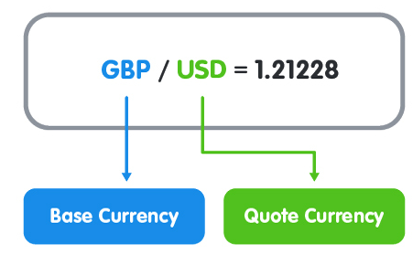

* When buying, the exchange rate tells you how much you have to pay in units of the quote currency to buy **ONE unit of the base currency**.
* In the example above, you have to *pay* **1.21228 U.S. dollars** to buy**1 British pound**.
* When selling, the exchange rate tells you how many units of the quote currency you get for selling **ONE unit of the base currency**.
* In the example above, you will *receive* **1.21228 U.S. dollars** when you sell **1 British pound**.

### Short/long

* Going short is selling (i.e. you are selling the base currency to get the quote currency)
* Going long is buying (i.e. buying the base currency using the quote currency)

## Flat or square

* No open position means you are “flat” or “square”
* Closing a position is “squaring up”

## Bid, ask and spread

* Forex prices are quoted with the bid and ask price
* Bid generally is < than the ask

### “Bid” price:

* The price at which your broker is willing to **buy** the base currency in exchange for the quote
* Bid is the best available price for you to sell it at

### “Ask” price:

* Price at which the broker will **sell** the base currency in exchange for the quote currency
* Ask is the best price for you to buy the currency